Loading dock delivery label for Melbourne Exhibition Centre (MEC)
This label must be attached to every item delivered
to the loading dock.
Entry to the Exhibition Centre loading dock is via Normanby Road, South Wharf.
For further information, please contact our Logistics team on 03 9235 8385.
Melbourne Convention and Exhibition Centre staff will only sign for deliveries between
8am–4pm, Monday to Friday. We will not accept responsibility for items left at the
loading dock outside of these times.
EXHIBITOR FREIGHT

Contact information
Contact name
(Person responsible for delivery)
Contact phone number
(Person responsible for delivery)

Event information
Event name | HIRE25 (Hire & Rental)
Event number | 117312
Event dates | Monday 02 Jun 2025 - Friday 06 Jun 2025
Room/area for delivery | Exhibition Bays 15-20

Stand information
Stand name
Stand number

Items
Item number
Total number of items

General information
The loading dock is managed and controlled by MCEC’s Logistics department.
- Children under 15 and animals are not permitted on any of the loading docks.
- A 30-minute parking limit applies for drop-off/pick-up of goods during the move in and move out process. Vehicles and their contents are the responsibility of the owner.

Exhibition Centre Doors 1-10
(Bays 1–20)
They run the full length of the Exhibition Centre and is 45m deep. The loading
dock narrows above the entries to the underground car park and behind the kiosks.
Traffic flows in a one-way direction
in from and out to Normanby Road. All vehicles entering the loading dock will
be required to check in at the boom gate.
If not manned, please use the intercom
and speak to security.

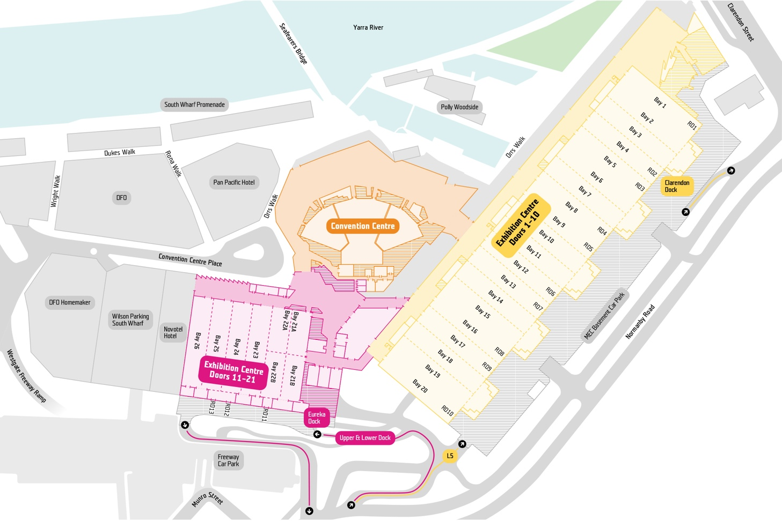
Exhibition Centre Doors 11-21
(Bays 21–26)
This loading dock is split across two levels (‘upper’ and ‘lower’). The upper dock is
at the same level as the floor of Exhibition Bays 21–26 and is the main dock used for Exhibition bump in’s. Adjacent to Door 11, is a separate loading area and door that provides access to the Eureka Meeting Rooms, Sovereign Room and Courtyard Meeting Rooms. The door provides access to the ground level servery and services lifts.
The lower dock is intended for use by smaller vehicles (up to 8m), couriers and exhibitors. This dock is at street level.
There is a ramp, stairs and two dock levellers to provide access between
the two loading docks.
Storage on the upper dock is not
permitted, however there is partially covered storage available on the lower
dock (under the freeway).
The Exhibition Centre Doors 11-21 (Bays
21–26) loading dock is linked via an internal road network to all existing loading docks.

